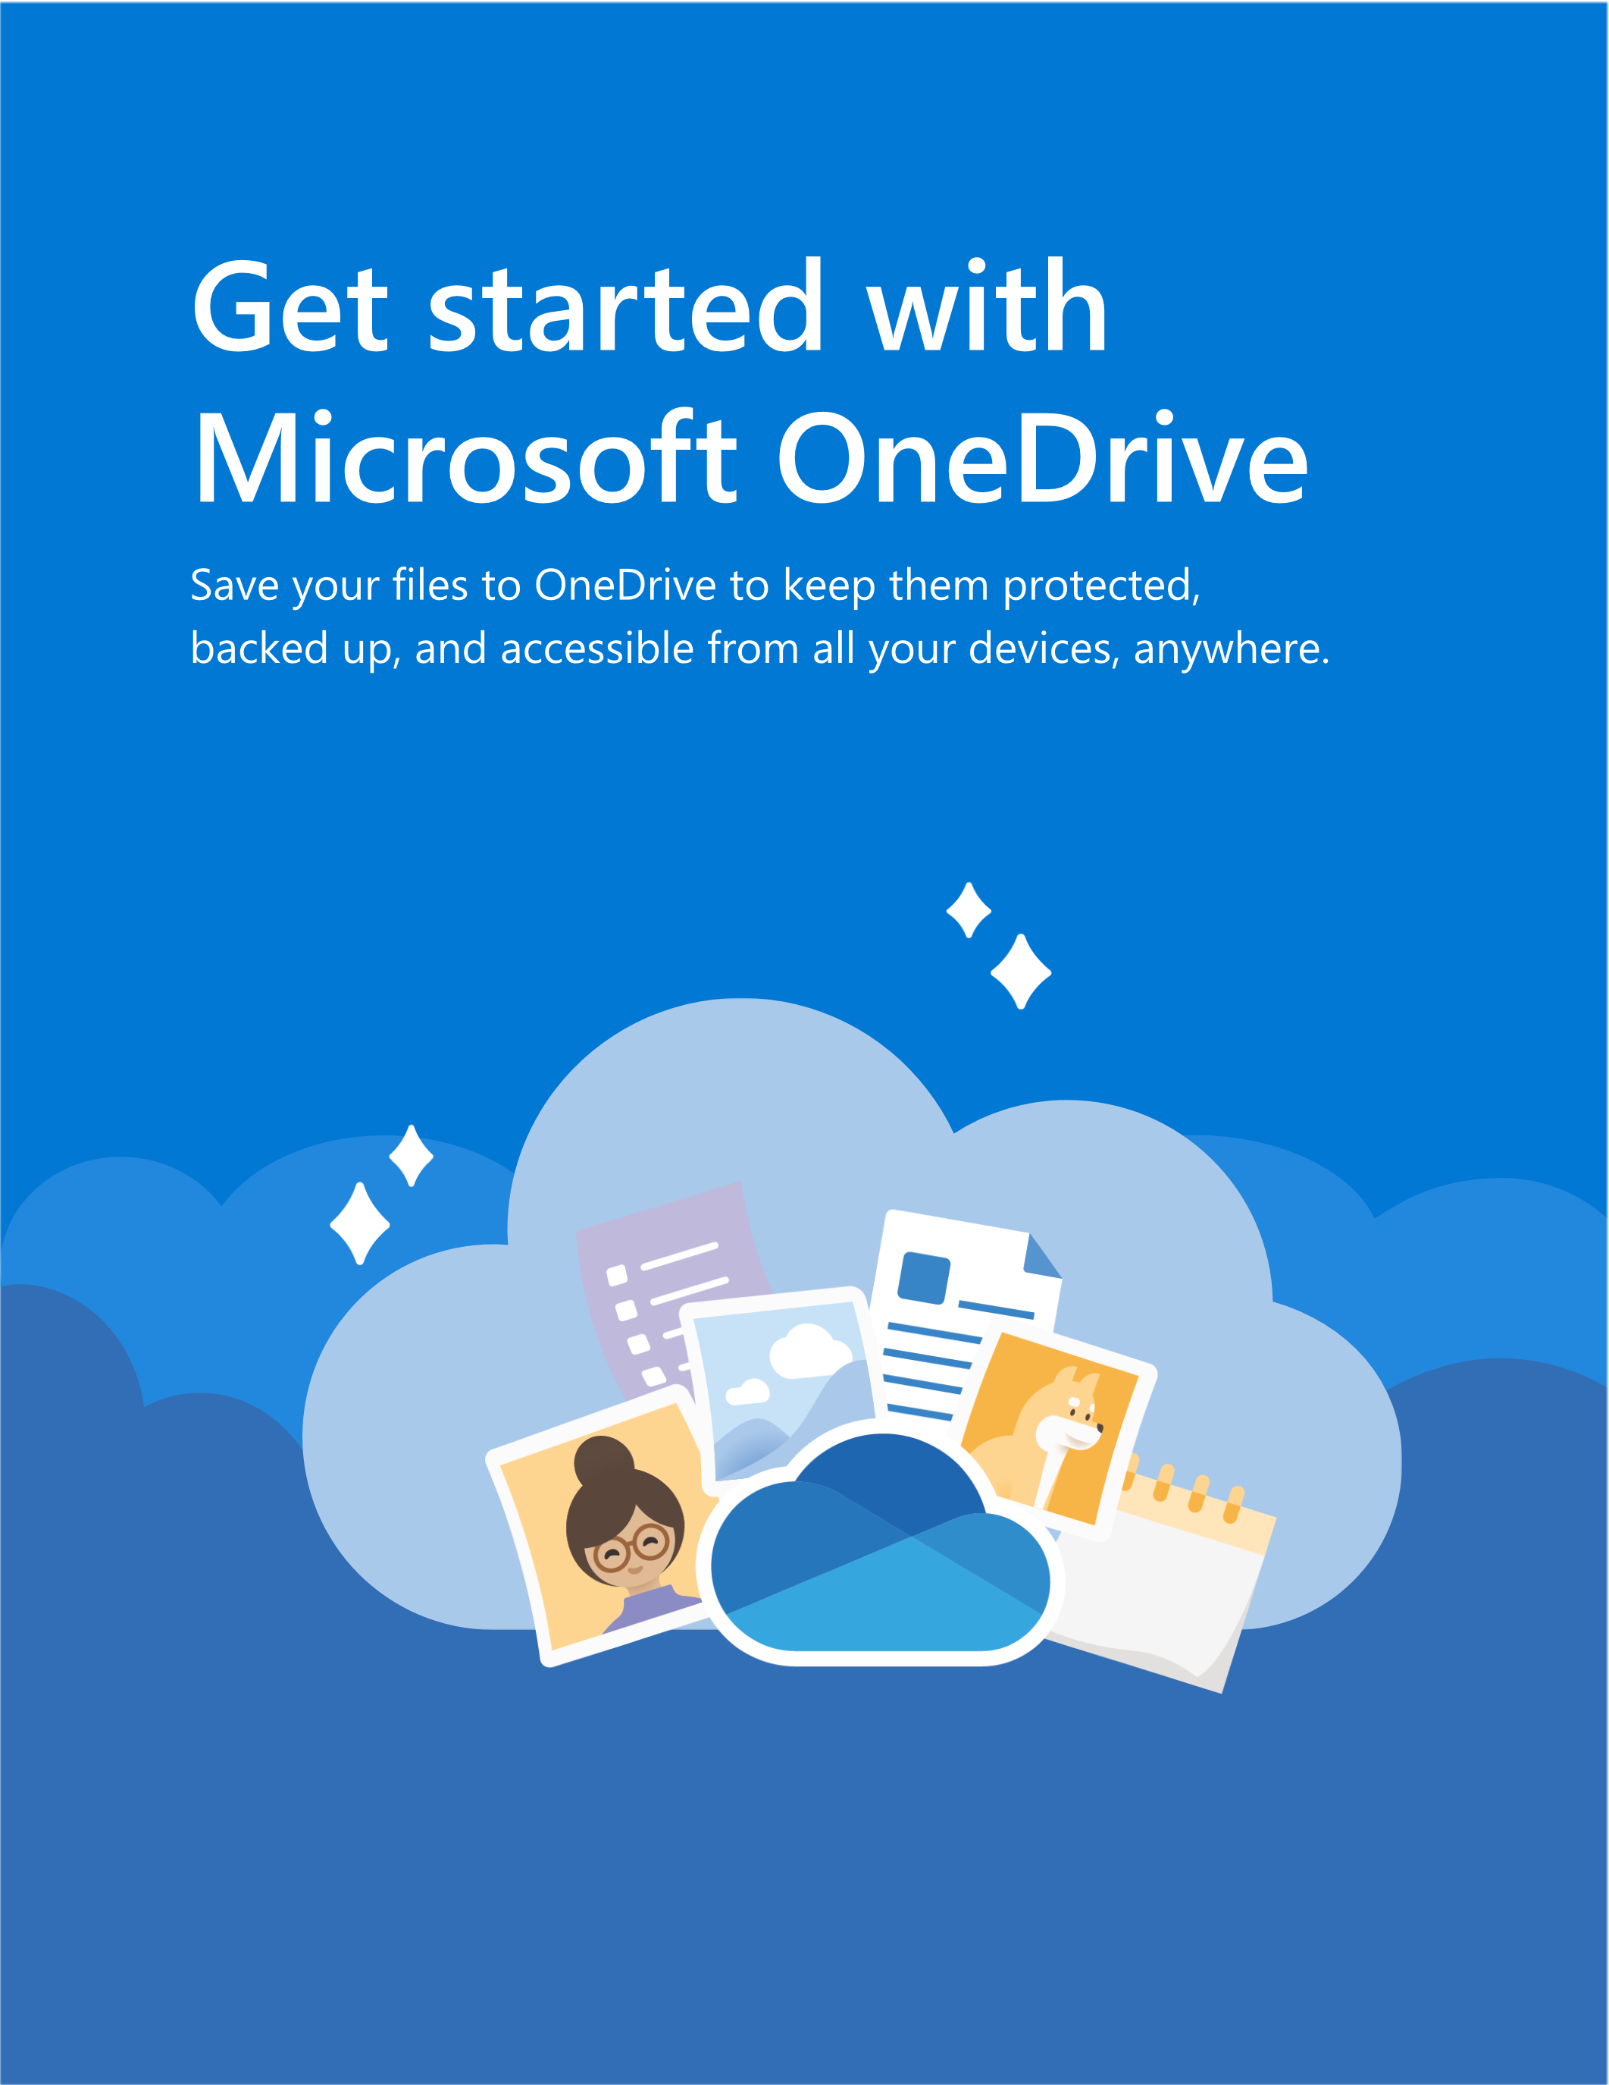
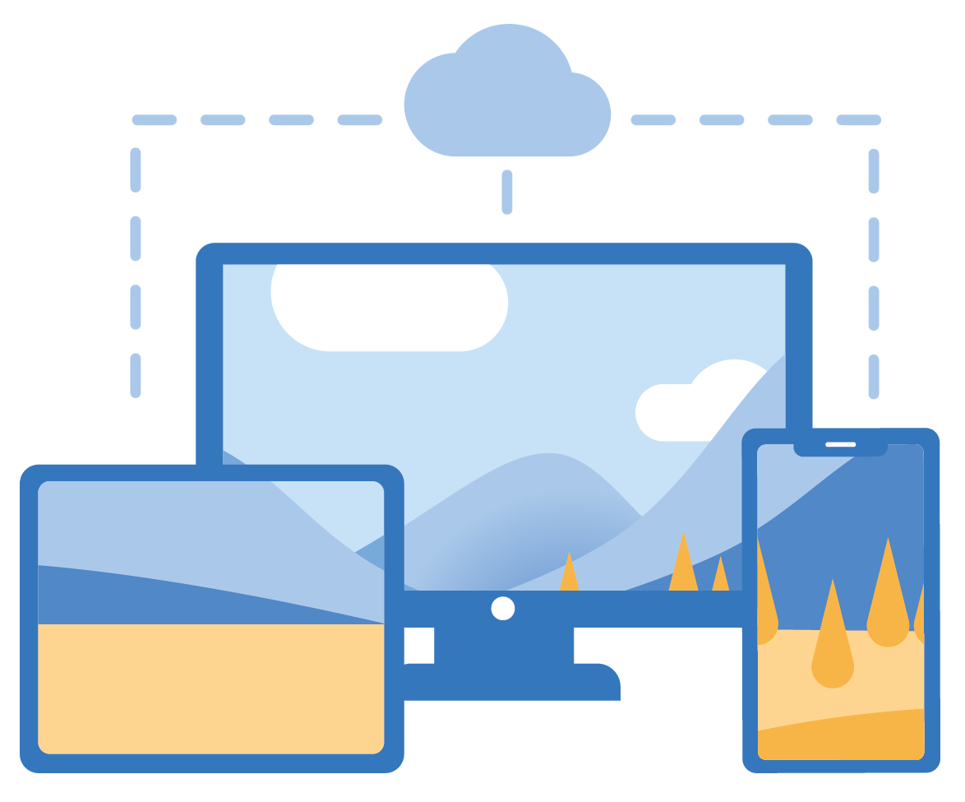
Anywhere access
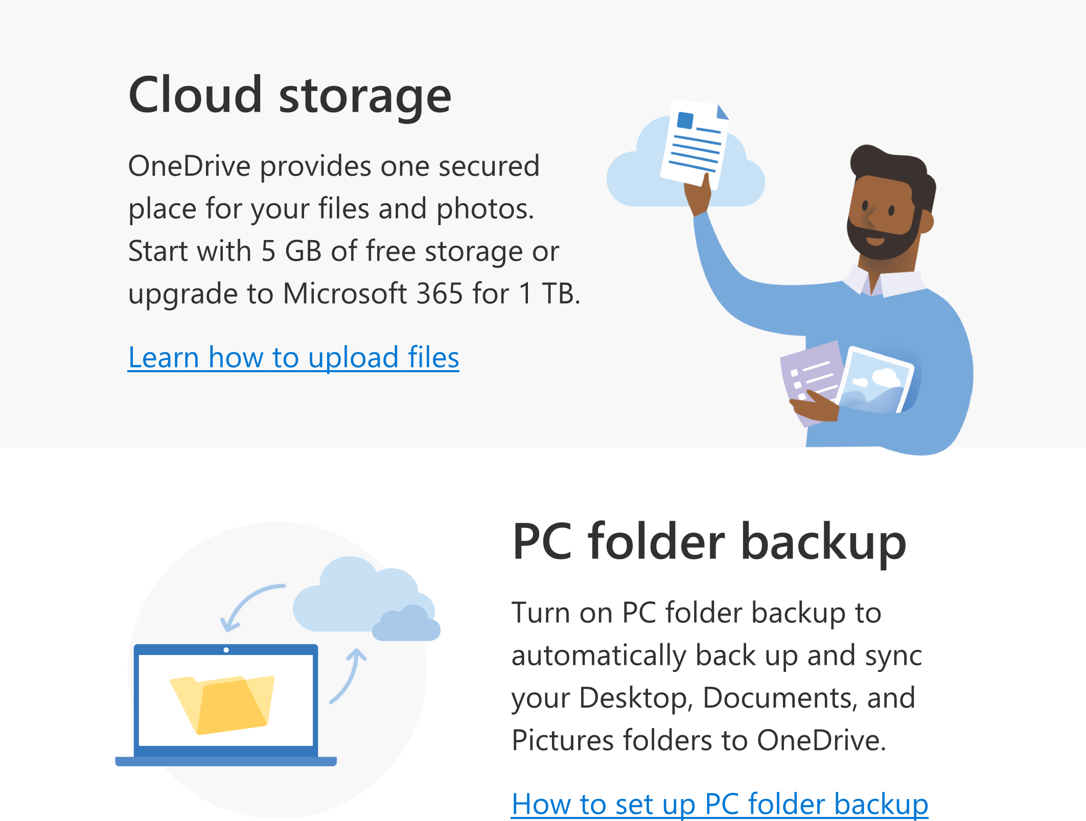
With OneDrive.com and the OneDrive mobile app you can
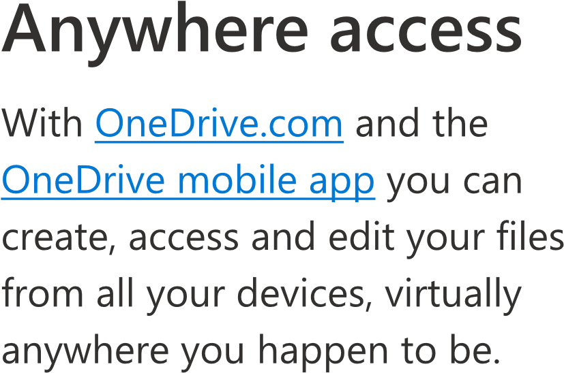
create, access and edit your files from all your devices, virtually anywhere you happen to be.
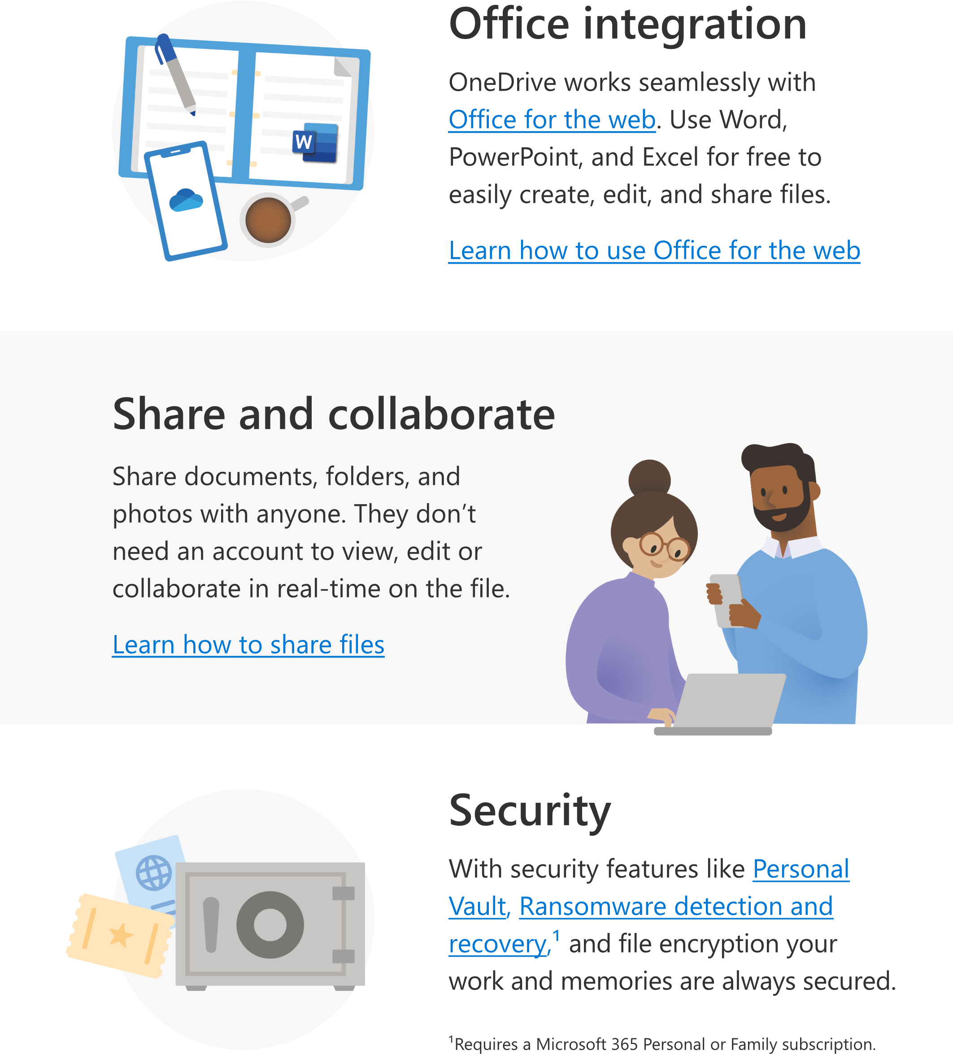
Get more features with the mobile app
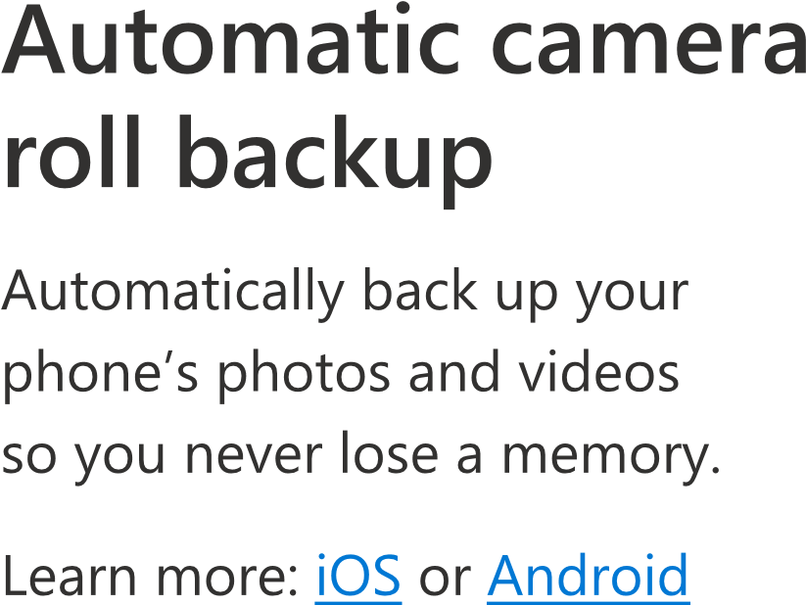

Automatic camera roll backup
Automatically back up your phone’s photos and videos so you never lose a memory.
help cente
r
On
e
Dr
iv
e
e

i
nformati
o
e
n
a
bout On
e
Dr
iv
vi
s
it the
Fo
r m
o
r
Learn more: iOS or Android
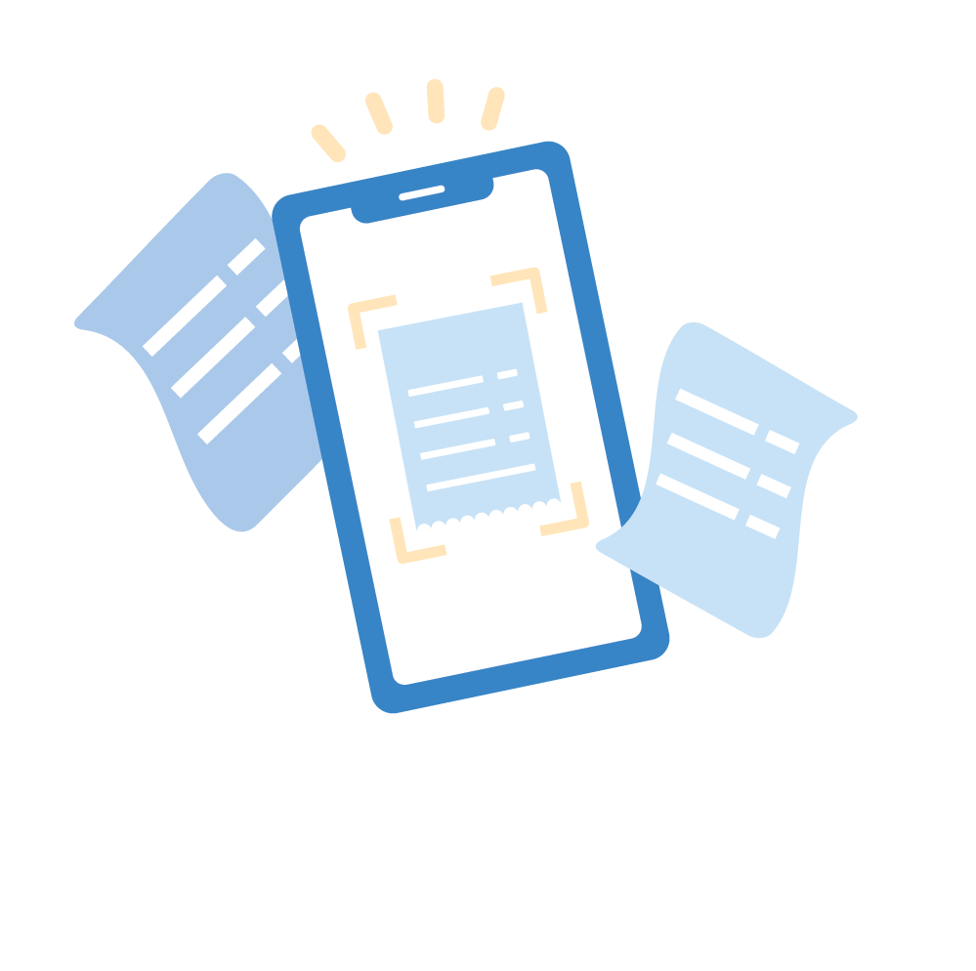
Scan and save paper documents
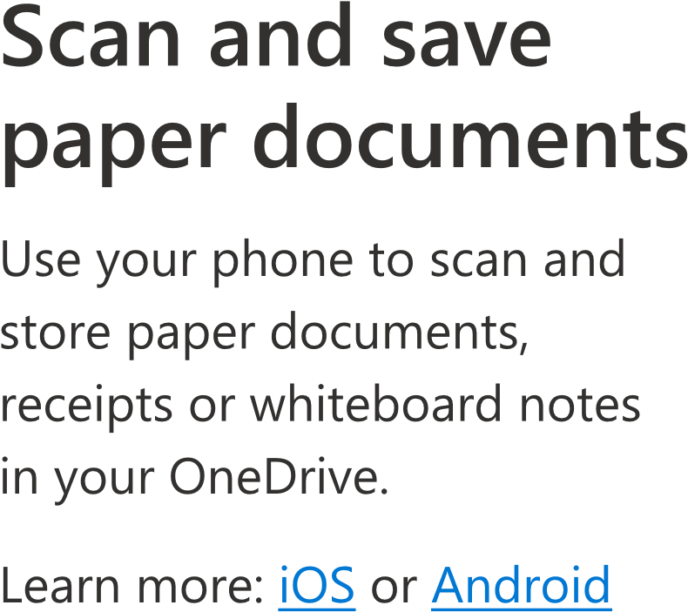
Use your phone to scan and store paper documents, receipts or whiteboard notes in your OneDrive.
Learn more: iOS or Android
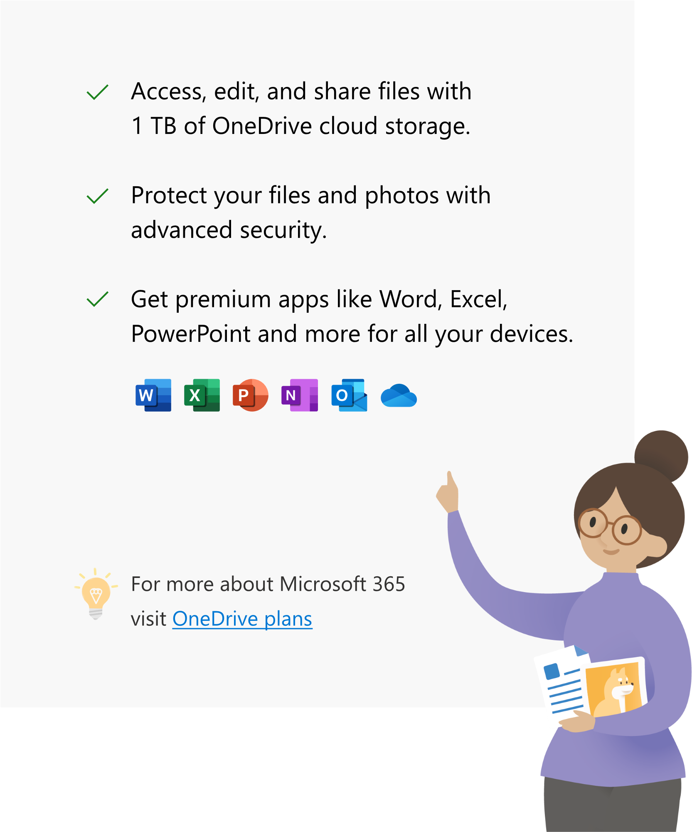
Be more creative, organized and secure with Microsoft 365

